"Cypress Trees, a beginning" is an artwork created in collaboration with British artist Anna Ridler and American artist Caroline Sinders. This machine generated the work of moving image delves into the complexity of the dataset and raises political questions about deforestation and climate change, memory and loss. Cypress Tree is a tree found along the Gulf Coast of the United States. These trees are capable of surviving for thousands of years, but are currently under threat from climate change. The artists used this dataset to train the Generative Adversarial Network to reflect what these areas would look like in the future with or without the trees.

According to the introduction, the work 'Cypress Trees, a beginning' uses a neural network model from a deep learning technique called Generative Adversarial Network (GAN). In this work, the artist used the GAN model to generate a large number of images of trees and then selected the most expressive ones for hand painting. This work struck a chord with me. Firstly, it provided more possibilities of computer art for me, a way of exploring the future of design through computers that I hadn't thought about before. Secondly, what attracted me most to this work was the synthesis of the images, the simulation effect was very interesting. In addition, both ‘Infinite Nature’ and ‘Intersections’ have something in common with ‘Cypress Trees’, a beginning, in that they are both artworks based on artificial intelligence and computer programs, and they both explore the possibilities of human creativity and computer algorithms, as well as exploring artistic expression through digital technology.

From this essay, I see the push of digital technology for art, which redefines the boundaries and expressions of art. It made me realize that digital technology is not just for computing or playing games or producing electronic products, but that in this age digital media is inseparable from our lives, and it can also give us more ways of thinking in the process of creating art or designing. In addition, I found that digital technology art expression offers more possibilities for exploring the future, it allows the viewer to be more aware of and respond to some existing social crises, climate crises etc. through this form of simulated visualization. Digital technology offers more possibilities for artistic creation by combining it with traditional artistic expression techniques.

Here is background information about the work:

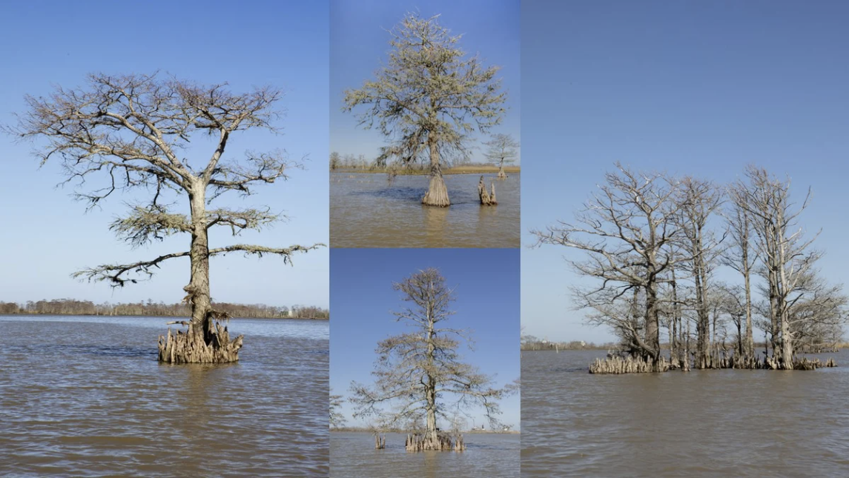

<https://feralfile.com/artworks/fragments-30-2051deg-n-90-1121deg-w-bsr?sort=0>

<https://www.artland.com/exhibitions/cypress-trees-a-beginning>

<https://ars.electronica.art/newdigitaldeal/en/cypress-trees/>

<https://carolinesinders.com/cypress-trees-a-beginning/>